The Compliance Trap: Why Easy Cancellations Without Save Attempts Are Costing Gyms More Than They Think

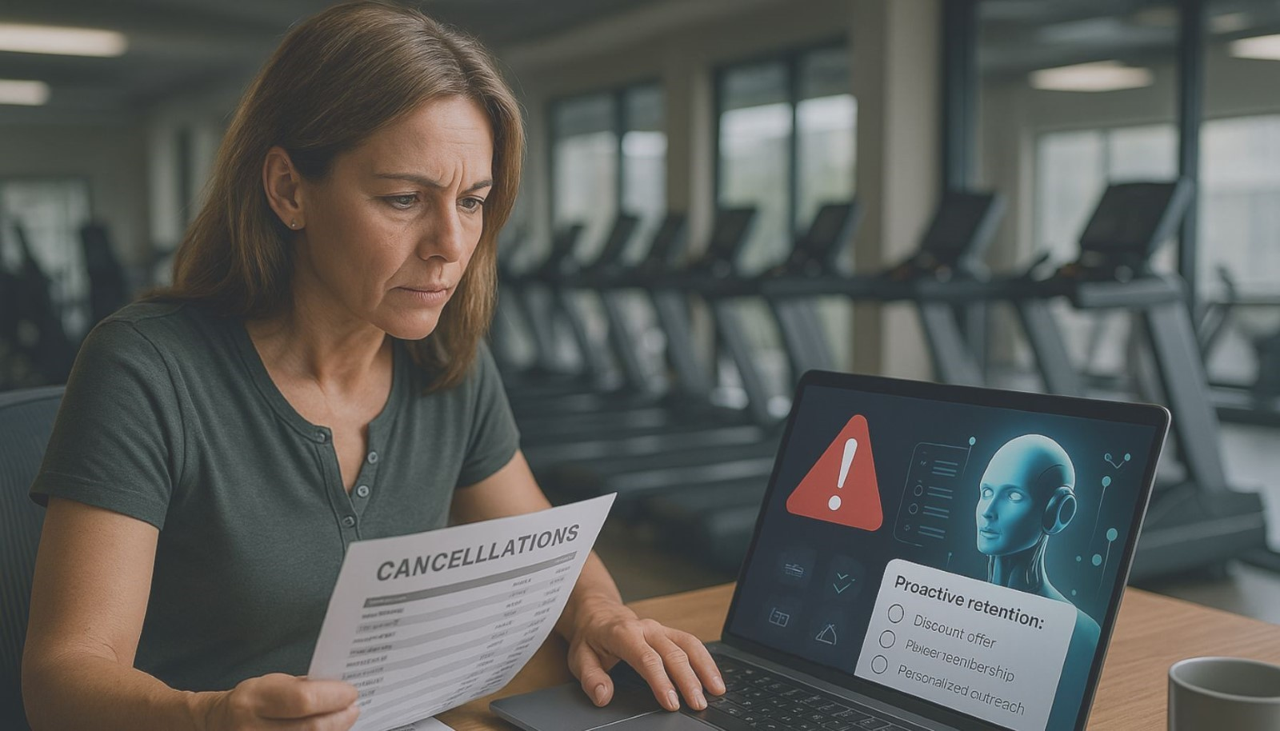

🕒 **On May 14, the FTC’s Click to Cancel rule goes into effect.** If your club plans to comply by simply enabling online cancellations—**but doesn’t have an intelligent save strategy in place**—you could be walking straight into a churn crisis.

**The Real-World Lesson: What Happened When a Gym Removed Save Attempts**

One of our clients was using **Click2Save**, our AI-powered cancellation interception tool. It worked exactly as intended: members who attempted to cancel were presented with personalized offers and flexible options, resulting in real, measurable saves.

Then, they made a fatal mistake.

They switched to a basic cancellation system that did *nothing* beyond compliance—**no engagement, no save offers, no retention tactics**.

The result?

* 📉 **Massive spike in cancellations**
* 💸 **Loss of thousands in recurring monthly revenue**
* 🤯 **No way to intervene once members hit "cancel"**

This wasn’t a technology problem—it was a **strategy gap**.

**Compliance ≠ Retention Strategy**

Yes, the **FTC Click to Cancel rule** requires you to make cancellations easy.

But if your platform only automates **gym contract cancellations**—and doesn’t offer **predictive analytics for fitness member retention**—you’re turning your website into a 24/7 churn engine.

Let’s be clear: **automation without intervention is revenue leakage.**

**What Operators Miss When They Ditch Save Attempts**

Here’s what’s missing in 90% of so-called “compliant” solutions:

* No **AI-driven gym membership retention strategies**
* No way to detect save opportunities using **predictive analytics**
* No mechanism to present **personalized offers** at the moment of cancellation
* No integration with core CRMs or scheduling systems

That’s exactly what **Click2Save AI gym retention tool** solves.

**Click2Save = Compliance + Conversion**

Click2Save doesn’t just process cancellation requests. It intercepts them in real time—**using AI to keep members you’d otherwise lose.**

Here’s what you get:

* 💡 **Predictive AI**: Anticipates churn before it happens
* 🧠 **Dynamic Save Offers**: Personalized deals based on member data
* 📊 **Retention Dashboards**: Real-time visibility into saves, saves missed, and revenue impact
* 🔌 **Seamless Integration**: Works with ABC, Mindbody, Daxko, and more

**Proven Results:**

* 📈 **Up to 15% of cancels saved**
* 💰 **Thousands in monthly recurring revenue protected**
* ⏱️ **Live in weeks—not quarters**

**What Fitness Leaders Should Be Asking Right Now:**

* Are we compliant *and* proactive with our cancellations?
* Do we use **AI to help reduce gym membership churn**—or are we relying on hope?
* How much revenue could we save by recovering just 10% of members trying to cancel?

If you're not sure, you're likely at risk.

**Final Word: Don’t Just Comply—Compete**

The **best retention software for fitness businesses** in 2025 won’t just check legal boxes—it will protect revenue and enhance member experience.

That’s why we built Click2Save.

✅ **Want to see how it works? Let us show you a** [**live demo**](https://calendly.com/meetwithron-dx/30min) **before May 14.**

**Blog Tags**

* **Click2Save**
* **Member Retention**
* **AI in Fitness**

**Meta Description (Under 155 Characters):**   
FTC's Click to Cancel rule is here. Learn why easy cancel setups without AI save attempts are costing gyms big on retention and revenue.

**Meta Title (Under 60 Characters)**   
The Compliance Trap: Why Click to Save Matters

<https://dxfactor.com/the-compliance-trap-click-to-save-vs-easy-cancel>

[https://dxfactor.com/the-compliance-trap-click-to-save-vs-easy-cancel?utm_source=rblinkedin&utm_medium=social&utm_campaign=marketing-usa &utm_term=click2save](https://dxfactor.com/the-compliance-trap-click-to-save-vs-easy-cancel?utm_source=rblinkedin&utm_medium=social&utm_campaign=marketing-usa%20&utm_term=click2save)